How to Run and execute this application,
Note : To Run this application we need to install a plugin or extension on Visual Studio Code
Below are the screen shots for the how to run and execution and testing
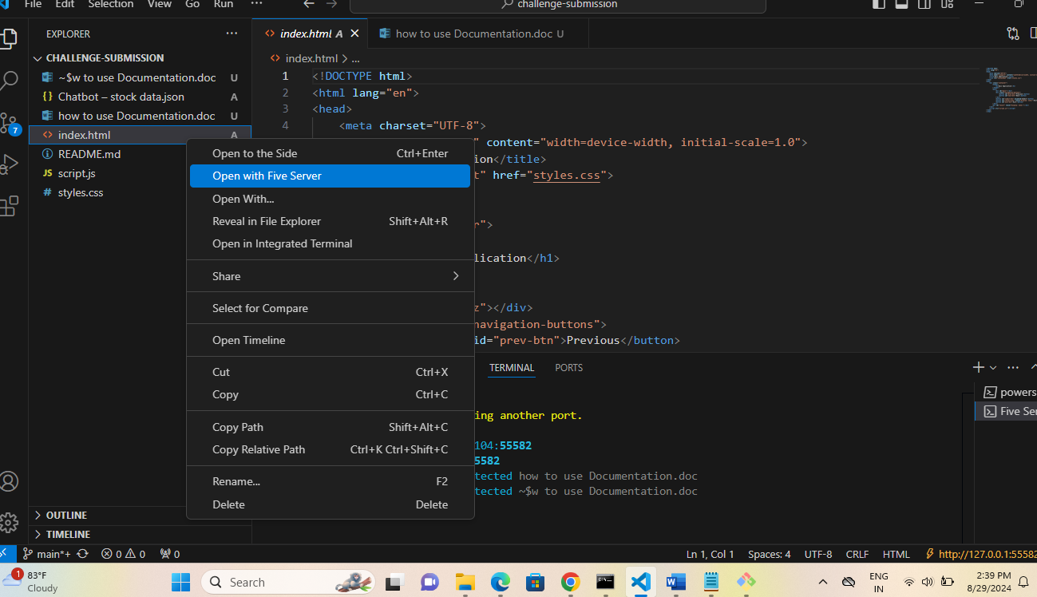
Step 1:
Once visual studio Extension added it a Live server , five server option would be visible
Right clink on index.html and select open with Five Server
Step : 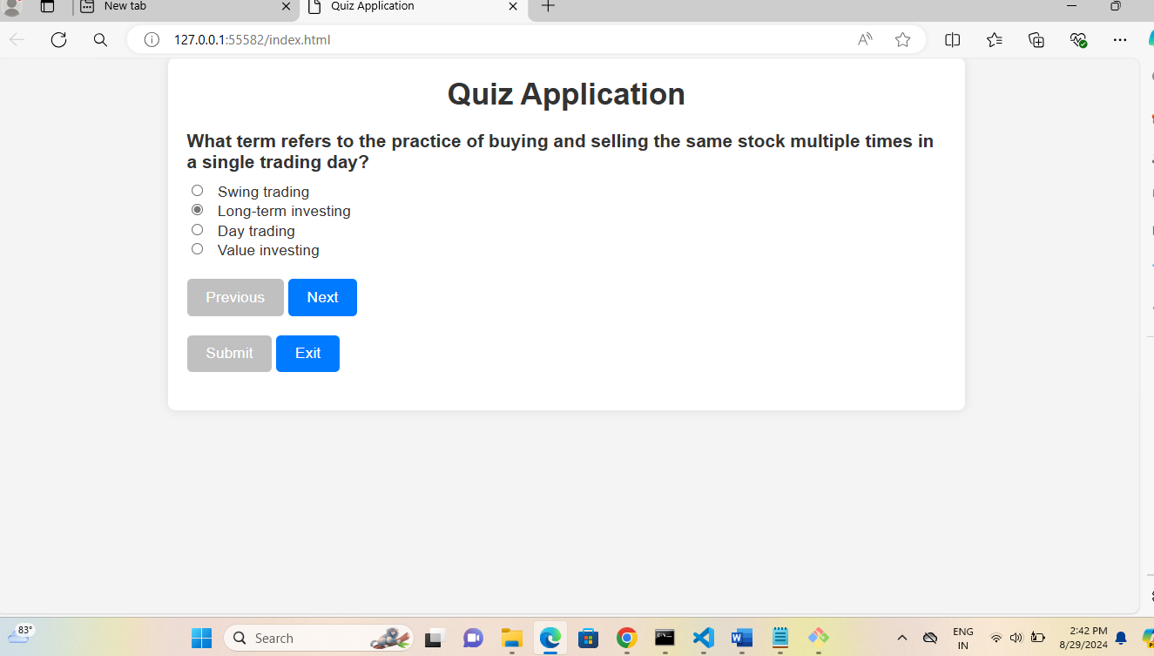
Step 2: once Application started you can see the above screen and you can start the Quiz application select answer and click Next at the end you can click Submit and exit below are the screen shot to follow.
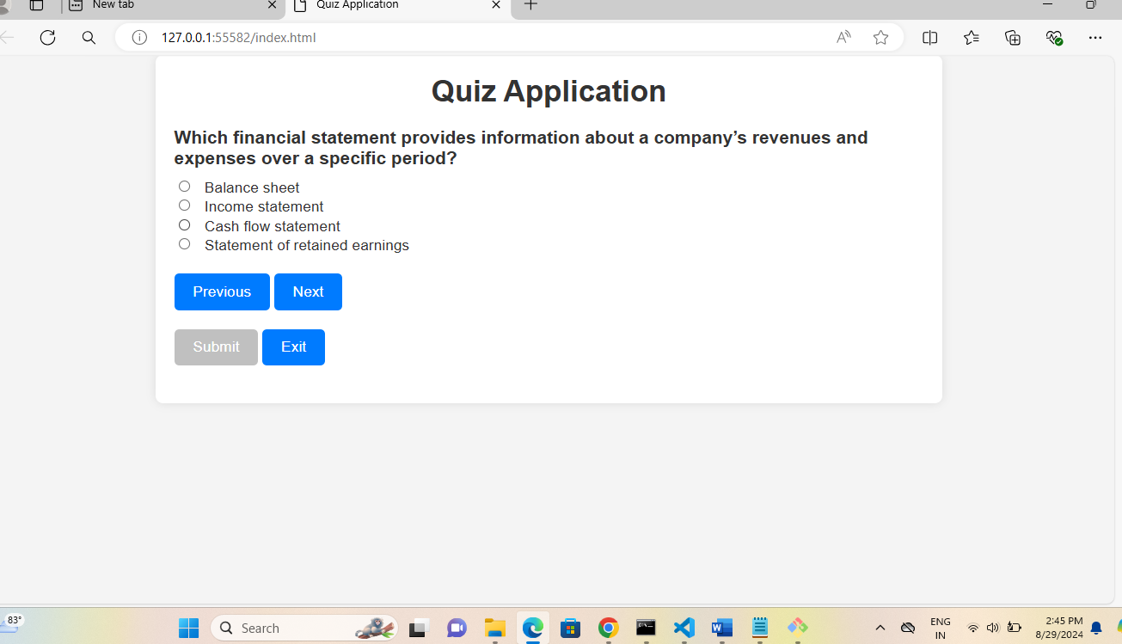

Step 3: Once you select all the answers and completed all question than only Submit button will be Enabled and Next Button will be disabled follow the below screen shot for reference

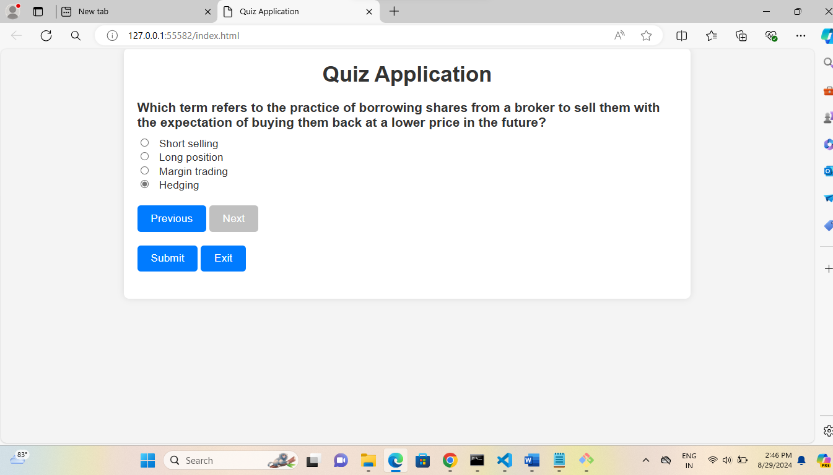

Step 4:
At the end once submission is done It will show all you Questions and answers form what you have selected and if required you can take RETAKE or click on Exit

